Name Mustafa
Sp23-bse-67
Class Diagram for student feedback system
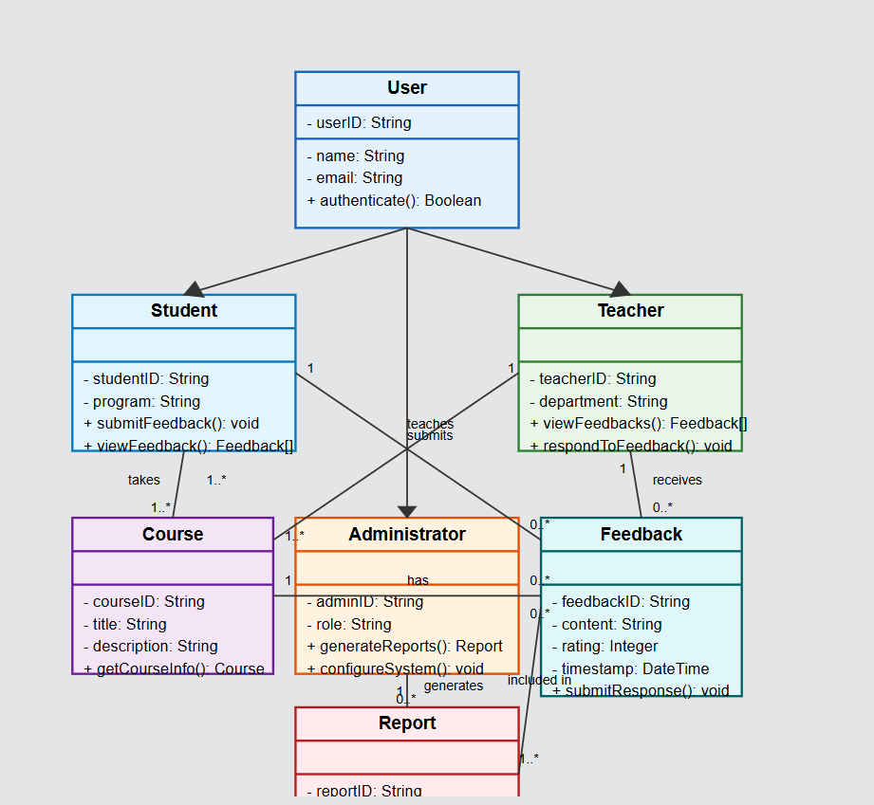

Core Classes:

1. User (Parent Class)
- Attributes: userID, name, email
- Methods: authenticate()
- Relationships: Parent class for Student, Teacher, and Administrator

2. Student (Extends User)
- Attributes: studentID, program
- Methods: submitFeedback(), viewFeedback()
- Relationships:
  - Takes multiple courses (many-to-many)
  - Submits feedback (one-to-many)

3. Teacher (Extends User)
- Attributes: teacherID, department
- Methods: viewFeedbacks(), respondToFeedback()
- Relationships:
  - Teaches multiple courses (one-to-many)
  - Receives feedback (one-to-many)

4. Administrator (Extends User)
- Attributes: adminID, role
- Methods: generateReports(), configureSystem()
- Relationships: Generates reports (one-to-many)

5. Course
- Attributes: courseID, title, description
- Methods: getCourseInfo()
- Relationships:
  - Has multiple feedback entries (one-to-many)
  - Taught by teachers (many-to-one)
  - Taken by students (many-to-many)

6. Feedback
- Attributes: feedbackID, content, rating, timestamp
- Methods: submitResponse()
- Relationships:
  - Submitted by students (many-to-one)
  - Received by teachers (many-to-one)
  - Associated with courses (many-to-one)
  - Included in reports (many-to-many)

7. Report
- Attributes: reportID, type
- Methods: exportData()
- Relationships:
  - Generated by administrators (many-to-one)
  - Includes feedback entries (many-to-many)

Key Relationships:
- Inheritance from User to Student, Teacher, and Administrator
- Many-to-many relationship between Student and Course
- One-to-many relationship between Teacher and Course
- One-to-many relationship between Student and Feedback
- Many-to-one relationship between Feedback and Course

